**JAVA CODING CHALLENGE**

**HOSPITAL MANAGEMENT SYSTEM**

**J502 ABHISHEK A G**

**OUTPUT SCREENSHOTS**

**GET APPOINTMENT BY DOCTOR:**

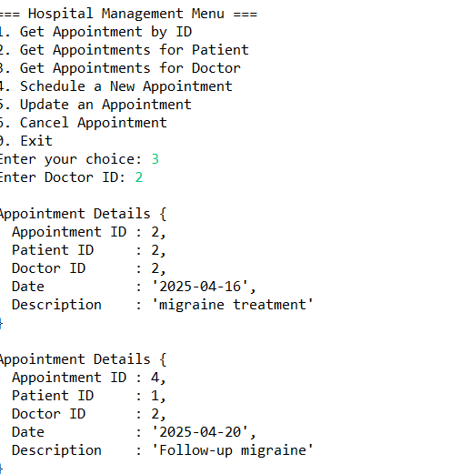

**GET APPOINTMENT BY PATIENT:**

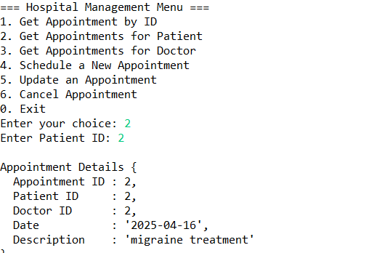

**CANCEL APPOINTMENT:**

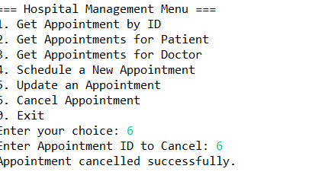

**SCHEDULE APPOINTMENT:**

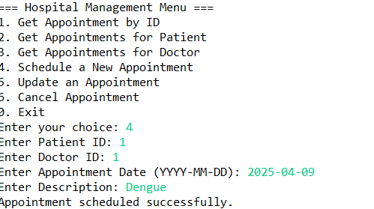

**UPDATING APPOINTMENT:**

